**Career Problem**

Getting your first job is a rewarding experience that often takes perseverance. My friend is in his last semester and is planning on looking for a job in the data field. In this project we will be tackling some of his questions and try to answer them with the help of data, so he could make a better decision.



**Assumptions**

1.Can apply for any data related job

2. Can go and work in any country

**Research Questions**

* Which Country offers the most number of jobs?
* Which employment type pays the most?
* What is the growth potential in terms of salary with experience level?
* Which field of data should I pursue with money being the prime motivator?
* How many Remote Jobs being offered?
* Are there Remote Entry Level jobs available ?
* How do the remote workers get paid? Do No remote jobs pay more ?
* Is company size an important consideration when looking for a job?

**Analysis and Findings**

The top 5 countries the most number of data related jobs, it seems like United States would be the best option to go for data jobs

155k is the median salary in the long term which is quite motivating. Even entry level jobs are paid good.

Machine learning scientist seems to be highly paid. 225K median salary right out of college is something of a dream come true. Even Business analyst and data analyst are good paying jobs for entry level experience.

Though the Contract type employment pays really well, the number of such jobs are very few. Mostly Full-time jobs are available.

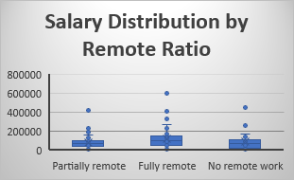

About 55% of jobs are Fully Remote, which means my friend can pursue his dream of being a digital nomad. The salaries are tempting as well for remote jobs, the box plot shows remote jobs have a median salary higher than both of the type of jobs. Not just that the salaries are far more distributed is Fully Remote and the maximum is also higher for it.

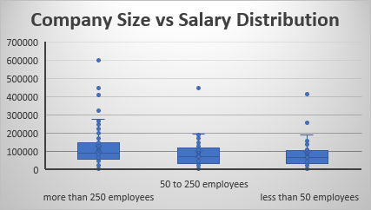

For a large company size i.e more than 250 employees has a higher median salary than small and medium size companies. The medium and small size companies have very similar median salaries.

Suggestions

1. I would advise my friend to go United States to look for data related jobs
2. He should try to find a job in a large size company
3. He should aim for a machine learning scientist/engineer job, as are highly paid
4. He could try and find a contract type job as they are paid more but very few of them are available
5. He could pursue his dream of being a digital nomad as plenty of Remote Jobs available even for entry level.